**CHAPTER TWO**

**LITERATURE REVIEW**

**2.1 INTRODUCTION**

A web scraping tool is a software that is used to scrape, mine or extract data from websites. Collecting data from websites can be done manually by users, but this process becomes really hectic and almost impossible when it involves the extraction of enormous data. Web scrapers help to automate this data collection process from websites by crawling through web pages. Web scraping libraries like beautiful soup scrapes HTML or XML documents and have appropriate python functions available for searching, traversing and modifying the HTML or XML tree to extract the desired data (Zhao, 2017). Companies and businesses need to feed on enormous amount of data to be able to identify trends, gain insight, predict outcomes, study the behavioral pattern of customers, identify business opportunities and strategically position themselves far ahead of their competitors (Majest, 2021).

Before the advent of web scraping, Sourcing data has always been a tremendous challenge to businesses that are constantly in dire need of bulky data to gain business insights. Web scrapers have made it easy to spy the websites of competitors in order to make strategic decisions. In this project, we utilize web scraping to extract data from ecommerce websites in order to effectively conduct price comparison for optimal online shopping. This tool will boost the user experience during online shopping as users will not be over worked about making the decision of the most optimal product to purchase. The online comparison application alleviates the stress of choice making by presenting the prices for a given product from different stores in a single intuitive web page.

**2.2 HISTORY OF WEB SCRAPING**

The world wide web was created by Tim Berners Lee in the year 1989 and shortly after, the first web scraper called “The Wanderer” was created by Mathew Gray in June 1993. The Wanderer was created for the sole aim of measuring the size of the web. After the invention of “The wanderer”, scientists were inquisitive and zealous to use this new technology of web scraping to power ideas and create solutions, Hence it did not take long before the first crawler-based web search engine called Jumpstation was launched that same year.

In the year 2000, salesforce and ebay launched an API crawler with which developers could gain access to their website’s data and functionalities. This caused a new revolution of web APIs as most other companies followed suit.

Web scraping has taken several forms since its invention. The first form of web scraping was manual copy-and-paste. This was done manually by humans and is not ideal for harvesting big data. Manual copy-and-paste technique of data scraping is very slow and prone to error since the procedure is not automated and is conducted by humans (Khder, 2021). Web scraping with time metamorphosed to include other techniques like regular expressions also known as pattern matching, HTML parsing and DOM parsing.

**2.3 TECHNIQUES OF WEB SCRAPING**

Web scraping can be implemented in a number of ways, each technique with its pros and cons. There are seven major techniques of web scraping that has been widely adopted since the inception of web scraping. These techniques are as follows

**2.3.1 Human Copy and Paste**

This is a manual technique where data to be scraped is copied and pasted by an individual or people. This process involves manually navigating to find relevant data, scraping the data and storing it in any desired data format. This technique is considered to be the first technique of web scraping and some people still do not regard it as web scraping due to the fact that it is not automated. It can be very tasking and takes up a lot of time to scrape significant amount of data. Perhaps, one of the major downsides of this technique is that it is prone to errors and can be almost impractical when scraping enormous data (Raul, 2014).

**2.3.2 Regular Expression and Text Gripping**

This powerful technique uses pattern matching techniques like regular expression and UNIX Gripping to scrape data. Programming languages like Python and Perl are mostly used to execute this technique and it is still widely adopted till this day. Regular expression is a special technique because it does not just scrape or index any data. It scrapes only data that matches the specified regular expression pattern.

Regular expression filters data from the webpage, selects data that matches the specified pattern and then extract the data. This extracted data can then be saved in other popular data formats such as XML, CSV or in a conventional database like SQL. Regular expression patterns can match different text or characters such as digits, non-digits, upper case characters, lower case characters, range of numbers, white space, special characters and many more.

Most languages like Python and Javascript have a specific module for performing regular expressions. Python’s module for regular expression is called the re module.

**2.3.3 Http Programming**

Scraping data from dynamic webpages can be difficult sometimes. Http technique is widely adopted to solve this challenge. HTTP request is sent to the server and a response is received by the browser containing scraped data to be stored in the database or any other data format.

A dynamic web page is simply a webpage that presents different content to different users while maintaining the same interface. Unlike a static web page that displays the same content to all users. Dynamic webpages change frequently making it more difficult to scrape since the HTML structure is not static

**2.3.4 Dom Parsing**

Modern Browsers like Chrome, Internet Explorer, Mozilla and many others have developer options where the Document Object Model of any webpage can be viewed. Data stored in the DOM tree is then scraped and stored. The DOM is a standard for obtaining, modifying, creating or deleting HTML elements from web pages (Rohmat & Alam, 2018).

Webpages are built using HTML and CSS. The details of websites are hidden within the markup language and can be extracted from the DOM. DOM parsing does more than just access data. DOM parsing is also used to manipulate and alter HTML documents.

**2.3.5 HTML Parsing**

This technique uses query languages like XQuery and HTQL for parsing HTML pages, thereby scraping data from the content of the HTML pages. This technique usually involves consuming and converting unorganized data into structured data that can be easily traversed and used. HTML parsing makes data retrieval easier as data can be accessed in a more structured pattern. XML documents can also be parsed due to its similar syntax to HTML.

HTML parsers process structured and organized markup documents like HTML and XML. Most languages have a specific modeule to handle HTML parsing. Python’s module for HTML parsing is the HTMLParser module. HTML parsing processes and transforms unstructured data into a format that’s easier to use and read.

**2.3.6 Vertical Aggregation Platforms**

Companies have been able to build custom bots to scrape data from popular websites. These bots have been programmed to self-simulate human activities by monitoring data trends and scraping data. This method has gained popularity due to its ability to extract large data automatically without the need for human intervention. Data retrieved from this technique is properly vetted before storing to ensure validity.

**2.3.7 Semantic Annotation Reorganizing**

Websites that support semantic annotations are scraped using this technique. The annotations are integrated into webpages and then parsed using DOM Parsing. Data can be pulled from any semantic layer of the webpage.

Semantic annotation technique involves tagging web contents with metadata to identify related contents. Tagging web contents semantically makes it easier to find contents on web pages. Scraping data involves finding desired data, then extracting the discovered data. Semantic annotation uses tagging to map contents faster on webpages when traversing and scraping data.

**2.4 PRESENT DAY WEB SCRAPING**

Web scraping has taken a new face over the years. A technology that started as basic manual copy-and-paste has now evolved into an innovation that has powered millions of businesses and startups. The major aim of web scraping is to extract data from websites. As the size of data to be extracted grew to become enormous, human copy-and-paste and basic regular expression could no longer serve for scraping data as this meant massive man-power and time would be required to extract meaningful amount of data.

Present day web scraping has evolved into an automated process. The abundant libraries for web scraping has also contributed positively to this evolution. In this present era, web scraping has proven its relevance in data analysis, marketing, leads generation and price monitoring. Scraped data is usually saved in an excel spreadsheet or CSV while sophisticated scrapers will integrate support for other data formats such as JSON which can then be used in APIs (Sirisuriya, 2015).

More than ever before, e-commerce businesses have been enlightened to understand the relevance of data to business advancement, Hence businesses invest a lot of resources to obtain big data. To effectively utilize data in business, Big data obtained has to be consumed appropriately to yield maximum business insights and in turn, Business advancement.

In this present dispensation, web scraping APIs have become more popular. Platforms like scrape.do, import.io, scrapy, scrapingdog, octoparse, parsehub and many others have taken the mind of developers as they provide developers with ease and access to a lot of web scraping functionalities without having to write too much complex code (Ozsahan, 2022). Most of these APIs even help overcome web scraping blockers by offering a feature called IP rotation which makes them less likely to be restricted from scraping websites by bot detectors.

**2.5 WEB SCRAPING AND ECOMMERCE**

Web scraping has pushed a lot of businesses into the limelight due to its vast use cases. There are different types of web scraping and each type has its unique role to play in the business sector. It is no longer news that businesses with great infrastructure will do well but businesses that position technology and innovation at the forefront will stay far ahead of its competitors. Web scraping has proven to be a vital strategy for e-commerce businesses to obtain rich data and customer insights. (Kasereka, 2021). E-commerce stores constantly need to spy on competitors to make moves due to the competitive nature of the e-commerce sector. This frequent monitoring can get really difficult and tasking when the frequency and degree of monitoring gets really high. E-commerce businesses cannot efficiently conduct price monitoring manually and this is where automated web scraping comes in to play.

From fundamental economics, The greater the competition, the lesser the price and the higher the quality of products (Doan & Simon, 1996). Web scraping promotes competition amongst e-commerce businesses by simplifying data insights and competitor spying. Thereby leading to a massive cut-down in outrageous pricings in the e-commerce sector. Web scraping does more than just price monitoring. e-commerce businesses can get insight about competitor’s strategy.

**2.6 REVIEW OF EXISTING SYSTEMS**

There are a number of web applications that use web scraping to monitor and compare the prices of products from ecommerce stores. Some of these applications make money by referring customers to online stores after comparison.

**2.6.1 Pricespy**

Pricespy(pricespy.co.uk) is a web and mobile application that utilizes web scraping and data feed to compare prices and products from over 6100 shops. The app has a nice and easy to use interface that makes it easy for customers to navigate and compare products online. Pricespy is absolutely free for customers but charge a certain fee from shops each time a customer is redirected to these online shops from their website. Pricespy updates product price three to five times daily to avoid the shop websites blocking their web crawlers.

The mobile application of pricespy can be downloaded on Google play store. Google playstore is a store where users can download games, apps and digital contents for their android devices. App ratings and reviews are also displayed on the platform to guide users on the best apps to use. Pricespy has ranked greatly on google playstore bagging over 1 million downloads.

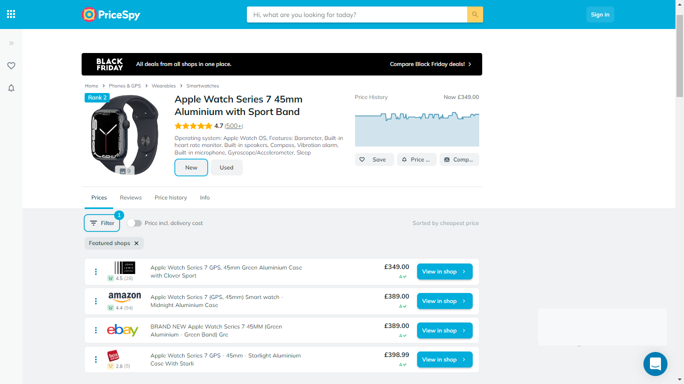

Figure 2.1 Image displaying the web interface of pricespy

(Source: pricespy.co.uk)

Some of the features of Pricespy include:

1. **Multiple Shops:** Compare product prices across 6100 shops. This way customers can make optimal shopping decisions
2. Product reviews and comments
3. **Price History:** View the price trend in a graphical format. This feature will show users how the price for a particular product has changed over time
4. **Save Product:** Discovered products can be saved and processed later.
5. **Multilingual:** Website can be viewed in English, French, Norwegian, Danish, Finish and others.
6. **Price Notification:** Users get notified when the product price drops to your desired price.

**2.6.2 Yahoo Shopping**

Yahoo shopping is an online comparison tool that compares price, track price changes and scrapes deals from online shops for optimal shopping. Yahoo shopping redirects customers to merchant websites but earn a small fee from these referral links. This platform displays products from a wide variety of shops and product categories to promote the satisfaction of customers.

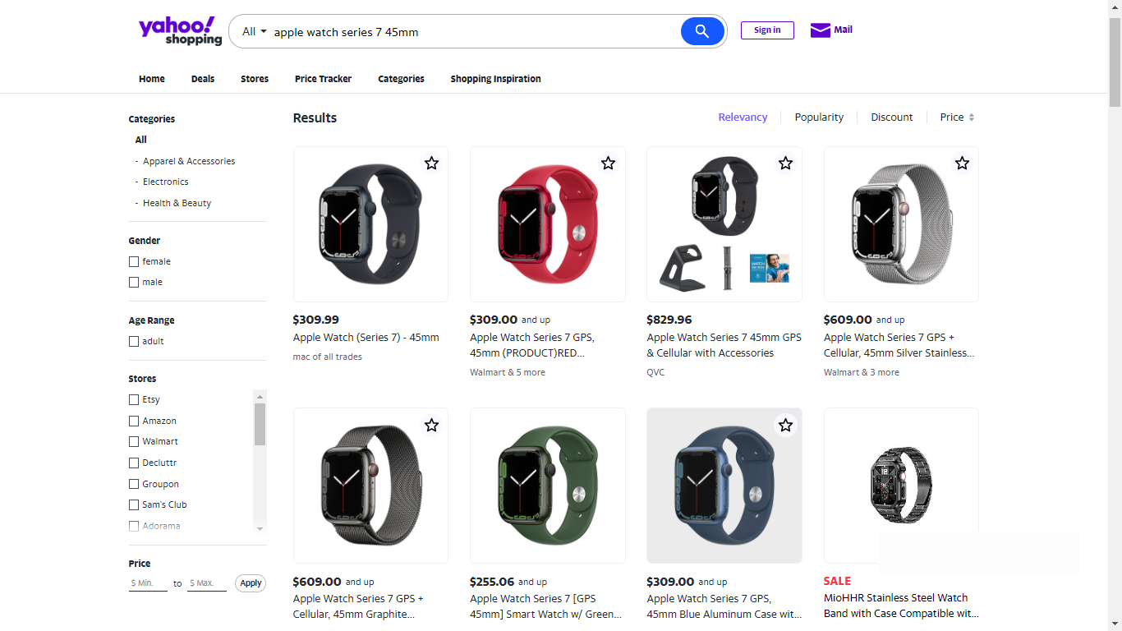

Figure 2.2 Image displaying the web interface of yahoo shopping

(Source: shopping.yahoo.com)

Some of the features of yahoo shopping include:

1. **Multiple Shops:** Compare product prices across multiple online shops. This way customers can make optimal shopping decisions
2. **Price Tracker:** This feature tracks the price of products added to wishlist and sends an alert when the price drops to the user’s affordable rate.
3. **Advanced search filter:** Product search can be trimmed down by setting criteria for products to be indexed such as maximum and minimum price. When a price filter is applied, only products within that price range will be displayed to the user.

**2.6.3 Shopbot.com**

Shopbot is an online comparison engine that uses web scraping to perform price analysis and compare products based on their price, reviews and features. Shop bot is an Australian company that conducts product comparison across products of diverse categories. Prices on the platform are updated daily but the final price on the merchant’s website could sometimes be slightly different from that on the comparison website as price updating is not implemented frequently.

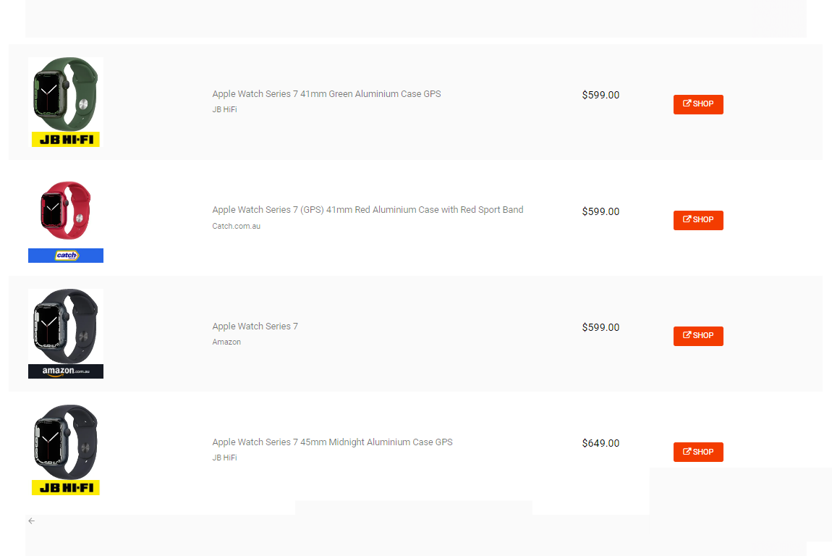

Figure 2.3 Image displaying the web interface of Shopbot

(Source: shopbot.com.au)

Some of the features of Shopbot include:

1. **Vast Product Categories:** Availability of vast product categories. The platforms covers electronics, gadgets, kiddies wears, Health and Beauty products and others.
2. **Simple Interface:** Intuitive web interface for easy navigation
3. **Awesome User Experience:** Price comparison in just few clicks

**2.6.4 Tweakers**

Tweakers is a Dutch website for comparing products, prices and shops. The website is multifunctional because it compares products, compare prices and also covers tech news on the homepage. Tweakers covers a lot of product categories.

The website tracks the location of location of visitors and offers website language options using Google translate. The two languages supported on the website are English and Dutch. When comparing product price, the website also displays reviews on the product been searched. These reviews can be user reviews in text format, or company reviews in video format.

Tweakers was built by a computer scientist called Femme Taken as a student’s hobby project in the year 1998. The technology has grown to become popular in Netherland and Belgium, winning multiple awards over the years. Currently, the web application has ammased over 1 million members, with its forum having more than 29 million posts. Tweakers was awarded website of the year, six times in a row starting from 2009.

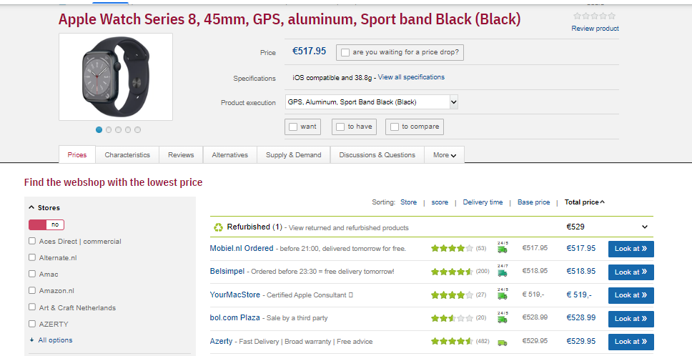

Figure 2.4 Image displaying the web interface of Tweakers.net

(Source: tweakers.net)

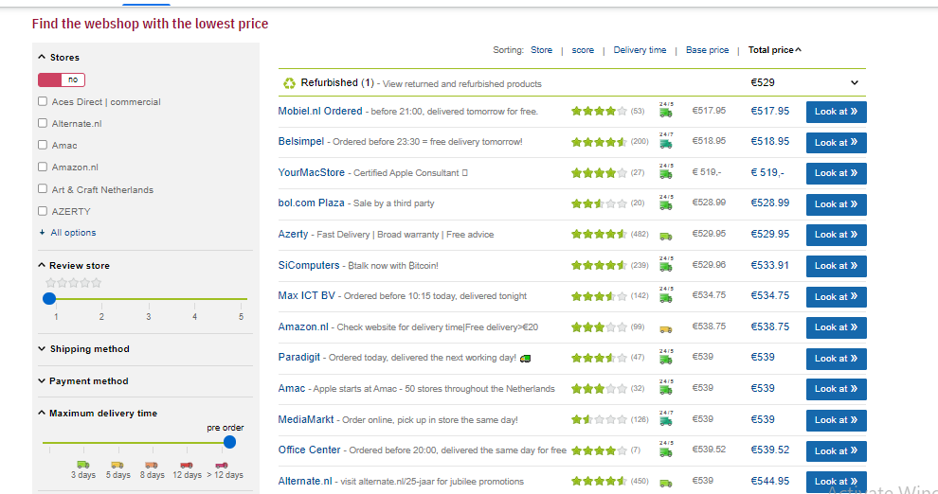

Figure 2.5 Image displaying the shop listing interface of Tweakers.net

(Source: tweakers.net)

Some of the features of Tweakers include:

1. **Multiple Shops:** Compare product prices across multiple online shops. This way customers can make optimal shopping decisions.
2. **General Product Review:** Tweakers display user and company reviews. These reviews have the capacity to influence the choice of buyers by pointing out the characteristics and experiences with the products. Users can also rate products by picking any rating from 1 to 5 star for the product.
3. **News Aggregator:** For each product searched, Tweakers displays all news stories related to the product searched. Thus, Tweakers functions both as a news aggregator and online price comparison tool.
4. **Advanced search filter:** Product search can be trimmed down by setting criteria for products to be indexed such as maximum and minimum price. When a price filter is applied, only products within that price range will be displayed to the user. Products can also be filter via star rating such that only products with 5 star rating will be displayed to the user.

**2.6.5 Getprice**

Getprice is an online price comparison website for finding the best deals in Australia. The website covers products from diverse categories such as electronics, computers, clothing and fashion, sports and traveling, health and beauty, kids and toys, office supplies, cars, accessories and many more.

Getprice also has a section for displaying news stories on products, ecommerce, sales and technology. The online comparison website compares products from over 360 stores. Getprice lists over 3.5 million products from more than 1200 retail outlets in Australia, pulling a monthly traffic of more than 1.5 million users.

The web application stands out due to its modest user interface, responsive design and intuitive layout. Making it easy for users to navigate and find products.

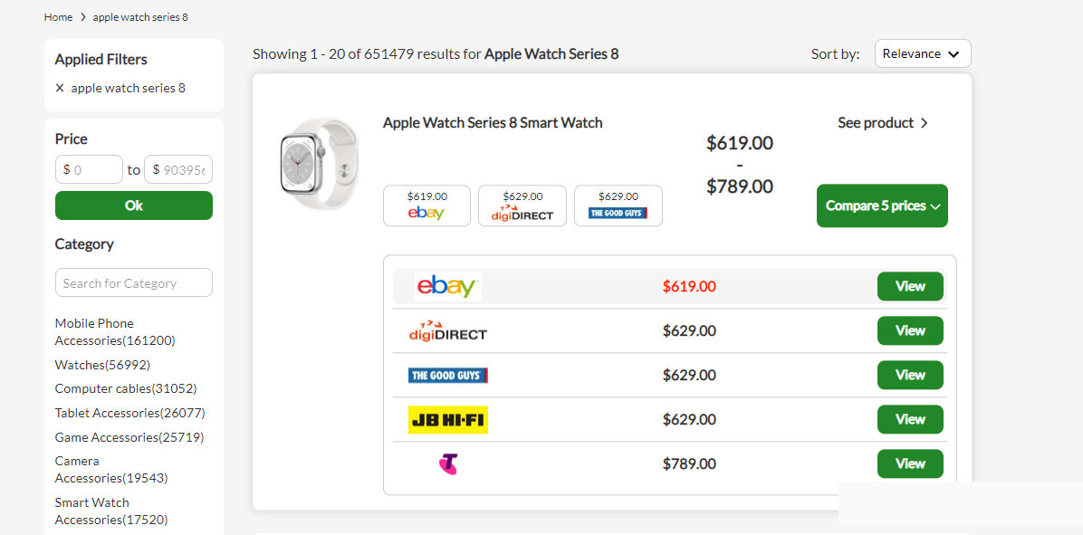

Figure 2.4 Image displaying the web interface of Getprice

(Source: getprice.com.au)

Some of the features of Getprice include:

1. **Multiple Shops:** due to the availability of vast shops in the web app, product prices can be compared across over 350 online shops. This way customers can make optimal shopping decisions.
2. **Advanced search filter:** Product search can be trimmed down by setting criteria for products to be indexed such as maximum and minimum price.
3. **Intuitive Layout and Interface:** Intuitive web interface for easy navigation. Making it easy for users to find optimal products

**2.7 FEATUES OF A WEB SCRAPER TOOL FOR ECOMMERCE STORES**

Web scraper tools for e-commerce businesses are built to satisfy the needs of online shoppers. For a web scraper tool to be exceptionally effective, it must possess certain vital features to be able to deliver top-tier service and standout from similar web applications.

**2.7.1 Intuitive Web Interface**

An intuitive web interface is an interface that is predictable and easy to understand. A web scraper tool should be easy to use without requiring the user to overthink. The more intuitive a web interface, the less confused a user is likely to get when using the web application. Bad web interface might require the user to go through some sort of tutorial to be able to understand and use the web application and this can be a turn-off to new customers.

**2.7.2 Ideal Price Comparison**

An ideal price comparison tool is one that is focused on satisfying customers by meeting the demands for which the customers visit the web application. Customers use comparison tools in order to find the best product as the most optimal price possible. The customer should get nothing short of this. A satisfied customer is definitely bound to return to complete more deals.

**2.7.3** **Advanced Search and Filters**

The ability to navigate and find desired products in the web application should not be difficult. Users should be able to narrow down their search based on certain criteria such as maximum and minimum price, discount percentage and shops. This saves time and resources as users will not have to navigate much before finding the product of their choice.

**2.7.4 Availability of Multiple Stores**

Customers use online comparison applications because they want to compare product prices across multiple shops before making purchase. The aim is defeated when there are no multiple credible shops to compare products across. Vetting shops before adding them to be comparison list will help build customer trust.

**2.7.5 Reliable and Authentic**

Product price on comparison websites should correspond with the price in the merchant’s website. Customers will feel frustrated if they notice a cheap price in the comparison website, only to find a more expensive price when they proceed to complete the purchase on the merchant's website. There should be a high degree of synchrony between prices on online comparison websites and merchant websites.

**2.7.6 Save Product Feature**

Customers should be able to save discovered products for later use. More like a cart feature where products that customers have indicated interest in will be saved for future processing. This feature will avoid customers searching repeatedly for the same products thereby saving time and resources.

**2.8 DRAWBACKS OF WEB SCRAPER TOOLS FOR ECOMMERCE**

**2.8.1 Lack of Trust**

Customer participation can dwindle if there is a noticeable absence of trust when shopping online. This lack of trust can be attributed to a number of factors ranging from uncertainty, bad past experience, poor user interface and experience, unsatisfied customer expectations and inconsistent price between merchants and comparison websites (Lanford, 2006). One way web scraper tools can curb this problem is to list only vetted online stores who have a track record of delivering quality products and top-tier products to customers.

**2.8.2 Web Scraping Blockers**

Most modern websites use certain techniques to block web scrapers from accessing the contents of their websites. This makes it extremely difficult to extract data from such websites. Some of such techniques include User behavior analysis such as CAPTCHA, IP address-based blocking, and IP rate limiting. These methods are usually put in place to differentiate human users from bots.

Some websites can monitor the rate of requests sent within a given time. The system will assume the user is a bot if the number of requests made is too high as only bots can send many requests more than a human can possibly generate within a short time frame.

**2.8.3 Constant Price Change**

Most web scraper tools for ecommerce like Pricespy update their price three to five times daily. Thus, price change will not be effected on the online web scraper tool if the change is effected. Advanced bot detectors will tend to block web scrapers if unlimited requests are made to the website been spied.

**2.8.4 Difficult to Verify Product Quality**

Ecommerce web scraper tools are simply a connecting link between the customers and online shops. These platforms are not the merchants in reality. Hence, they cannot totally vouch for the quality of the products they recommend to you. Customers who find optimal products through an online comparison website tend to blame online comparison tools for faulty purchased items. Failing to understand that these platforms are simply connecting links to the original merchant stores. As a result, Most modern web applications like pricespy and yahoo shopping have terms and condition embedded on their websites to help customers better understand the terms and conditions binding the services rendered. Customer satisfaction is dependent on service quality and delivery (Brown & Jayakody, 2008).

**2.9 TERMS ASSOCIATED WITH WEB SCAPER TOOLS**

Below are some terms used and their definitions.

1. **API**

API is the acronym for Application Programming Interface which represents a software that helps two applications communicate and interact.

1. **Bot**

A bot is a software or program created to simulate human activity. Bots are automated to perform tasks without human intervention.

1. **XML**

XML is the acronym for Extensible Markup Language. This is a set of codes and tags that are used to store and share structured data across systems and networks.

1. **JSON**

JSON stands for JavaScript Object Notation and it is a common text-based data format for storing and sharing data comprising of collections of key-value pairs.

1. **Feed**

A program that provides users or websites with new and updated contents from a source application

1. **Interface**

Interface is the element of interaction between users and computers, making it possible for users to send input to and receive output from the application.

1. **Libraries**

A Library is a collection of closely connected modules bundled together to help programmers easily implement tasks.

1. **CSV**

A CSV (comma-separated values) is a text file for holding data separated by commas where each line of the file represents a data record allowing data to be stored in a table structured format.

1. **Parsing**

Parsing is the process of converting a code or program into a format that a runtime environment can execute or run.

**REFERENCES**

Comparison of Web Scraping Techniques:Regular Expression, HTML DOM and Xpath . (2018). *International Conference on Industrial Enterprise and System Engineering*, 283.

Brown, I., & Jayakody, R. (2008). B2C e-Commerce Success: a Test and Validation of a Revised Conceptual Model . *Electronic Journal Information Systems Evaluation,Volume 11,Issue 3* , 167.

Doan, R. J., & Simon, H. (1996). *Power Pricing.* Free Press Publishings.

Kasereka, H. (2021). Importance of web scraping in e-commerce. 1-3.

Khder, A. M. (2021). Web Scraping or Web Crawling: State of Art, Techniques, Approaches and Application. *International Journal of Advances in Soft Computing & Applications*, 147.

Lanford, P. (2006). E-Commerce: A Trust Perspective. *International Conference on Internet Computing*, 1-3.

Majest, E. (2021, November 17). *Why is data important for your business?* Retrieved 11 30, 2022, from majesteye.com: https://www.majesteye.com/why-is-data-important-for-your-business/

Ozsahan, H. (2022). *12 Best Web Scraping Tools in 2022 to Extract Online Data*. Retrieved 11 30, 2022, from popupsmart: https://popupsmart.com/blog/web-scraping-tools

Raul, H. (2014, October 22). *Top 7 Techniques of Web Scraping Only Experts Use*. Retrieved December 1, 2022, from loginworks: https://www.loginworks.com/blogs/160-techniques-of-web-scraping

Rohmat, G., & Alam, R. (2018). Comparison of Web Scraping Techniques: Regular Expression, HTML DOM and Xpath. *International Conference on Industrial Enterprise and System Engineering* , 283.

Sirisuriya, D. (2015). A Comparative Study on Web Scraping. *International Research Conference, KDU*, 137-138.

Zhao, B. (2017). Web scraping. *Encyclopedia of big data*, 1-2.